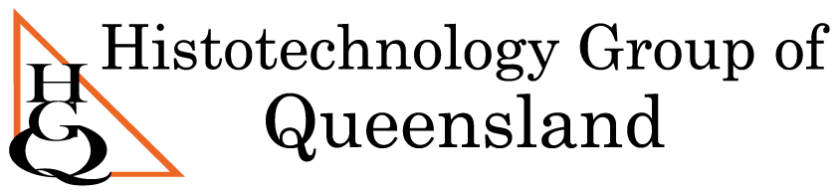

Histotechnology Group of Queensland Trivia Night
When: June 24th 2022, 6:30pm-10pm
Where: Normanby Hotel , Parlour Lounge, 1 Musgrave road Spring Hill.
Price: $30 (Tables of 10)
Includes: Dinner, Trade Sponsored Prizes, Professional Trivia Host
Limited spaces, Please Rsvp and pay by 10th June
Please fill out the Registration form available on the website www.hgq.org.au and email to Emma_Hughes@snp.com.au with your table filled out to ensure groups are kept together.

